**DAY:27 RESUME BUILDING WITH AI**

**Simple Resume Generator**

**Step 1: Input Collection**

# Resume Input Collection (with Certifications)

name = input("Enter your full name: ")

email = input("Enter your email address: ")

phone = input("Enter your phone number: ")

linkedin = input("Enter your LinkedIn profile URL (optional): ")

summary = input("Write a short professional summary: ")

skills = input("Enter your skills (comma-separated): ")

education = input("Enter your education details: ")

experience = input("Enter your work experience: ")

certifications = input("Enter your certifications (comma-separated, optional): ")

**Step 2: Install reportlab**

!pip install reportlab

**Step 3: Generate the Styled Resume PDF**

from reportlab.lib.pagesizes import LETTER

from reportlab.pdfgen import canvas

from reportlab.lib import colors

# Set up the PDF file

file_name = "Styled_Resume.pdf"

c = canvas.Canvas(file_name, pagesize=LETTER)

width, height = LETTER

# Styling Functions

def section_title(y, title):

c.setFont("Helvetica-Bold", 14)

c.setFillColor(colors.darkblue)

c.drawString(50, y, title)

c.setFillColor(colors.black)

return y - 20

def add_paragraph(y, text, font_size=11, leading=15):

c.setFont("Helvetica", font_size)

text_obj = c.beginText(50, y)

text_obj.setLeading(leading)

text_obj.textLines(text)

c.drawText(text_obj)

return y - (text.count('\n') + 1) * leading

# Header (Name & Contact)

c.setFont("Helvetica-Bold", 22)

c.drawCentredString(width / 2, height - 50, name)

c.setFont("Helvetica", 12)

c.drawCentredString(width / 2, height - 70, f"{email} | {phone} | {linkedin}")

y = height - 100

# Sections

y = section_title(y, "Professional Summary")

y = add_paragraph(y, summary)

y = section_title(y, "Skills")

y = add_paragraph(y, "\n".join([f"- {skill.strip()}" for skill in skills.split(',')]))

y = section_title(y, "Education")

y = add_paragraph(y, education)

y = section_title(y, "Work Experience")

y = add_paragraph(y, experience)

if certifications.strip():

y = section_title(y, "Certifications")

y = add_paragraph(y, "\n".join([f"- {cert.strip()}" for cert in certifications.split(',')]))

# Save and show message

c.save()

print("✅ Styled resume generated and saved as 'Styled_Resume.pdf'")

**Step 4: Download the PDF**

from google.colab import files

files.download("Styled_Resume.pdf")

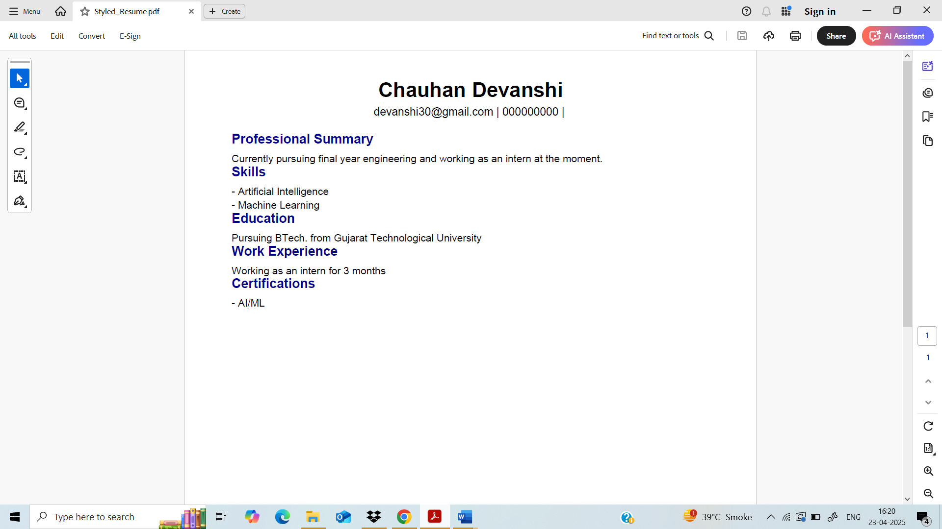

**AI Version: Use OpenAI API (with your API key)**

**Step 1: Input Collection + GPT Prompt Construction**

import openai

import getpass

# Securely enter your API key

openai.api_key = getpass.getpass("Enter your OpenAI API key: ")

# User Inputs

name = input("Enter your full name: ")

job_role = input("Enter your desired job role: ")

education = input("Briefly describe your education: ")

experience = input("Briefly describe your work experience: ")

skills = input("List your key skills (comma-separated): ")

projects = input("Mention any projects or achievements: ")

certifications = input("List certifications (optional): ")

# Construct prompt for GPT

prompt = f"""

Generate a professional resume for the following candidate:

Name: {name}

Job Role: {job_role}

Education: {education}

Experience: {experience}

Skills: {skills}

Projects: {projects}

Certifications: {certifications}

Please structure it with:

- Professional Summary

- Skills

- Education

- Work Experience

- Projects

- Certifications

Return only the resume content, clean and ready for formatting into a PDF.

"""

**Step 2: Get GPT Response (Generate Resume Content)**

# Call the OpenAI API with your resume prompt

response = openai.ChatCompletion.create(

model="gpt-3.5-turbo", # Use "gpt-4" if you have access

messages=[{"role": "user", "content": prompt}],

temperature=0.7,

max_tokens=1000

)

# Extract resume content

resume_text = response['choices'][0]['message']['content']

print("✅ AI-Generated Resume Content:\n")

print(resume_text)

**Step 3: Convert AI Resume Text into PDF**

from reportlab.lib.pagesizes import LETTER

from reportlab.pdfgen import canvas

from reportlab.lib import colors

# Create PDF file

file_name = "AI_Generated_Resume.pdf"

c = canvas.Canvas(file_name, pagesize=LETTER)

width, height = LETTER

# Add Name as title

c.setFont("Helvetica-Bold", 20)

c.setFillColor(colors.darkblue)

c.drawCentredString(width / 2, height - 50, name)

# Set up resume text

c.setFont("Helvetica", 11)

text = c.beginText(50, height - 90)

text.setLeading(15)

text.textLines(resume_text)

c.drawText(text)

# Save the PDF

c.save()

print("✅ Resume PDF saved as 'AI_Generated_Resume.pdf'")

**Step 4: Download PDF in Google Colab**

from google.colab import files

files.download("AI_Generated_Resume.pdf")